**PROGRAM:**

import java.io.*;

import java.util.*;

class Student //display() setName() setAge() setMarks()-overloaded calculateTotal()

{

String name;

int age,m1,m2,m3,flag;

int[] marks;

static Scanner sc = new Scanner(System.in);

Student()

{

name = "unknown";

age = 23;

m1=m2=m3=0;

flag = 0;

marks = new int[5];

}

Student(String name,int age)

{

this.name = name;

this.age = age;

m1=m2=m3=0;

flag = 0;

marks = new int[5];

}

public void display()

{

System.out.println('\n' +"Name: "+ name + '\n' + "Age: " + age + '\n' + "Total: " + calculateTotal()+'\n');

}

public void setName()

{

System.out.println("Enter the name: ");

name = sc.next();

}

public void setAge()

{

System.out.println("Enter the age: ");

age = sc.nextInt();

}

public void setMarks(int a,int b,int c)

{

flag = 1;

m1 = a;

m2 = b;

m3 = c;

}

public void setMarks(int arr[])

{

int i=0;

flag = 2;

for(int a: arr)

{

marks[i]=a;

i++;

}

}

public int calculateTotal()

{

int total=0;

if(flag==1)

{

total = m1 + m2 + m3;

}

else

{

for(int a:marks)

total += a;

}

return total;

}

}

public class ClassAndObject {

public static void main(String[] args) {

System.out.println("\n-- CLASSES AND OBJECTS --\n");

Student h = new Student();

h.setName();

h.setAge();

h.setMarks(88,86,87);

h.display();

Student g = new Student("devan",22);

g.setMarks(new int[]{50,50,50,50,50});

g.display();

}

}

**OUTPUT:**

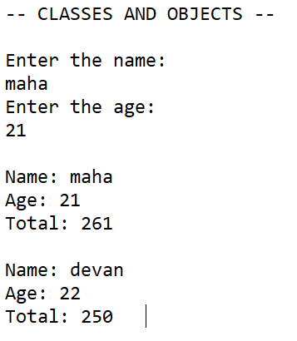

**RESULT:**

**PROGRAM:**

import java.io.*;

import java.util.*;

class Teacher

{

private int id;

private String name;

private float sal;

Scanner in = new Scanner(System.in);

Teacher(int id,String name)

{

this.id = id;

this.name = name;

}

Teacher(int id,String name,float sal)

{

this.id = id;

this.name = name;

this.sal = sal;

}

public int getId(){

return id;

}

public String getName(){

return name;

}

public float getSal(){

return sal;

}

public int getNoOfBookCanTake()

{

return 3;

}

}

interface courses

{

public String[] getCourses();

}

interface placement

{

public String[] getAttendedCompanies();

}

class MCAstudent extends Teacher implements courses,placement

{

int marks;

MCAstudent(int id,String name,int marks)

{

super(id,name);

this.marks = marks;

}

void setMarks(int marks)

{

this.marks = marks;

}

int getMarks()

{

return marks;

}

public String[] getCourses()

{

String[] courses={"OPERATING SYSTEM","C PROGRAMMING"};

return courses;

}

public String[] getAttendedCompanies()

{

String[] atndComp={"TCS","ZOHO"};

return atndComp;

}

public int getNoOfBookCanTake()

{

return 2;

}

}

public class Inheritpoly {

public static void main(String[] args)throws IOException {

System.out.println("\n-- Inheritance and Interface --\n");

int id,marks;

String name;

// float sal;

Scanner sc = new Scanner(System.in);

System.out.println("Enter the id: ");

id = sc.nextInt();

sc.nextLine();

System.out.println("Enter the name: ");

name = sc.nextLine();

System.out.println("Enter the marks: ");

marks = sc.nextInt();

MCAstudent t1 = new MCAstudent(id,name,marks);

System.out.printf("\nID : %d\nName : %s\nMarks : %d\n",t1.getId(),t1.getName(),t1.getMarks());

courses c = t1;

System.out.print("Courses : ");

System.out.println(Arrays.toString(c.getCourses()));

placement p = t1;

System.out.print("Attended Companies : ");

System.out.println(Arrays.toString(p.getAttendedCompanies()));

System.out.println("The no. of books can take in library: "+t1.getNoOfBookCanTake());

}

}

**OUTPUT:**

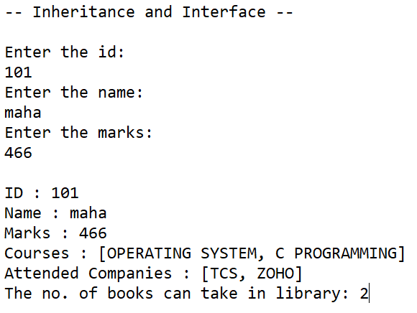

**RESULT:**

**PROGRAM:**

import java.util.Scanner;

import java.util.ArrayList;

import java.util.Iterator;

//example of java synchronized method

class Table{

static int maxval=Integer.MIN_VALUE,resval=0;

public synchronized void printTable(int a,int b){ //synchronized method

int cnt,max=Integer.MIN_VALUE,result=0;

for(int i=a;i<=b;i++)

{

cnt=0;

for(int j=2;j<i;j++)

{

if(i%j==0)

{

cnt++;

}

}

if(cnt>max)

{

result = i;

max = cnt;

}

}

if(maxval<=max)

{

maxval=max;

resval=result;

}

System.out.printf("The number that has maximum number of divisors from %d to %d is : %d",a,b,result);

System.out.println();

System.out.println("Count = "+max);

}

public int[] getFinalResult()

{

return new int[]{maxval,resval};

}

}

class MyThread extends Thread{

Table t;

int a,b;

MyThread(Table t,int a,int b){

this.t=t;

this.a=a;

this.b=b;

}

public void run(){

t.printTable(a,b);

}

}

public class TestSynchronization2{

public static void main(String args[]) throws Exception{

Scanner sc = new Scanner(System.in);

int value, kvalue;

int[] result = new int[2];

Table obj = new Table();//only one object

System.out.println("Enter the value: ");

value = sc.nextInt();

MyThread[] t = new MyThread[10];

//1000

kvalue = value/10; //100

int j=1,k=kvalue;

for(int i=0;i<10;i++)

{

t[i] = new MyThread(obj,j,k);

t[i].start();

j+=kvalue;//1 101

k+=kvalue;//100 200

}

for(int l=0;l<10;l++)

t[l].join();

result = obj.getFinalResult();

System.out.printf("Result: %d Count: %d \n",result[1],result[0]);

}

}

**OUTPUT:**

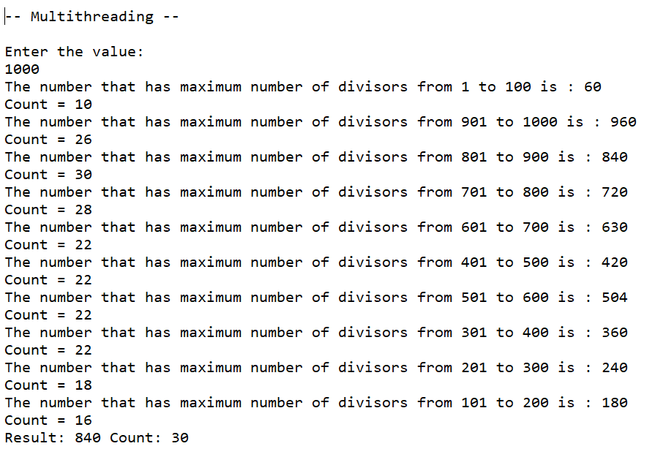

**RESULT:**

**PROGRAM:**

import java.io.File;

import java.io.FileReader;

import java.io.FileNotFoundException;

import java.io.IOException;

public class ExceptionDemo {

static void arithmeticException(int a,int b)

{

try{

System.out.println("Result = "+(a/b));

}catch(Exception e){

System.out.println("Exception message: "+e.toString());

}

}

static void nullPointerException(String str)

{

System.out.println("Length = "+str.length());

}

static void fileNotFoundException()

{

try{

File file = new File("E://file.txt");

FileReader fr = new FileReader(file);

}catch(Exception e){

System.out.println("Exception message: "+e.toString());

}

}

static void numberFormatException(String str)

{

try{

int num = Integer.parseInt(str);

System.out.println("Integer = "+(num-5));

}catch(Exception e){

System.out.println("Exception message: "+e.toString());

}

}

static char indexOutOfBounds(int pos)

{

String str = "mahadevan";

return str.charAt(pos);

}

static void userDefined(int num)throws GreaterThanTenException

{

if(num>10)

{

throw new GreaterThanTenException("Greater than 10 exception");

}

}

public static void main(String[] args) {

System.out.println("\n-- Exceptions --\n");

try{

System.out.println("passing null to a function that requires a string causes NullPointerException");

ExceptionDemo.nullPointerException(null);

}catch(Exception e){

System.out.println("Exception message: "+e.toString());

}

System.out.println();

System.out.println("Opening a file might cause FileNotFoundException if the file is not there");

ExceptionDemo.fileNotFoundException();

System.out.println();

System.out.println("Dividing any value by 0 causes ArithmeticException");

ExceptionDemo.arithmeticException(1,0);

System.out.println();

System.out.println("Passing a character string instead of number string causes this error");

ExceptionDemo.numberFormatException("hel");

System.out.println();

System.out.println("passing index above 8 causes this error");

char ch=' ';

try{

ch = ExceptionDemo.indexOutOfBounds(13);

System.out.println("Char ch = "+ch);

}catch(Exception e){

System.out.println("Exception message: "+e.toString());

}

System.out.println();

try{

ExceptionDemo.userDefined(22);

}catch(Exception e){

System.out.println("Exception message: "+e.toString());

}

}

}

class GreaterThanTenException extends Exception

{

GreaterThanTenException(){}

GreaterThanTenException(String msg){

super(msg);

}

}

**OUTPUT:**

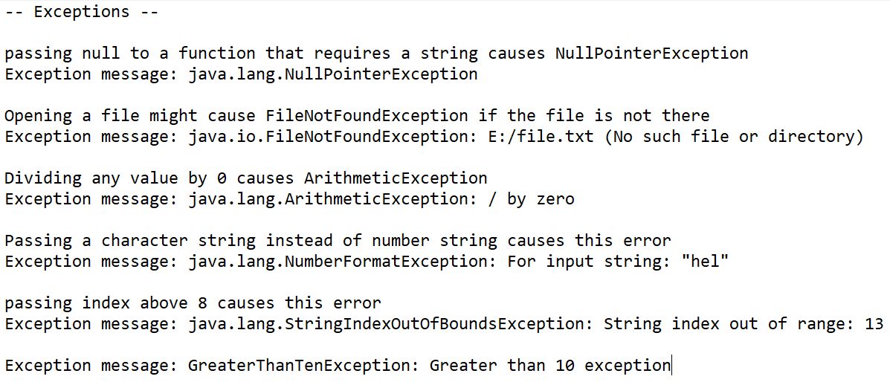

**RESULT:**

**PROGRAM:**

**PackageDemo.java**

import addition.PackageAccess;

public class PackageDemo{

public static void main(String args[]){

PackageAccess obj = new PackageAccess();

System.out.println(obj.add(100, 200));

}

}

**PackageAccess.java**

import addition.PackageAccess;

public class PackageDemo{

public static void main(String args[]){

PackageAccess obj = new PackageAccess();

System.out.println("Using Package to access the function add(), Result:"+obj.add(100, 200));

}

}

**OUTPUT:**

**package.PNG**

**RESULT:**

**PROGRAM:**

import java.io.*;

import java.util.Scanner;

class StreamDemo

{

public static void main(String[] args)throws IOException

{

String yourFile = "input.txt";

// Scanner sc = new Scanner(System.in);

// String yourContent=sc.nextLine();

String yourContent="Genius Ganesh";

File tmpDir = new File(yourFile);

if(tmpDir.exists()){

FileOutputStream fos = new FileOutputStream(yourFile);

fos.write(yourContent.getBytes());

fos.flush();

fos.close();

FileInputStream fis = new FileInputStream(yourFile);

int data;

int count =0;

while((data=fis.read()) != -1)

{

System.out.print((char)data);count++;

}

System.out.println(count);

}

}

}

**OUTPUT:**

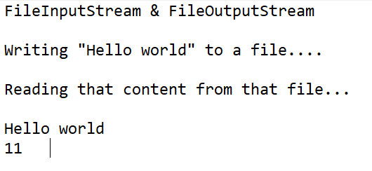

**RESULT:**

**PROGRAM:**

import java.sql.*;

import java.util.Scanner;

class OracleCon{

static Scanner sc;

private static Connection con=null;

private static Statement stmt=null;

static{

sc = new Scanner(System.in);

}

public static void main(String args[]){

try{

//step1 load the driver class

Class.forName("oracle.jdbc.driver.OracleDriver");

//step2 create the connection object

con = DriverManager.getConnection(

"jdbc:oracle:thin:@localhost:1521:xe","system","thepassword");

//step3 create the statement object

stmt=con.createStatement();

String createSql = "create table emp(id number(10),name varchar2(40),age number(3))";

int j = stmt.executeUpdate(createSql);

if(j == 0)

{

System.out.println("Table is created");

}

else

{

System.out.println("Table is not created");

}

System.out.println("Enter the no. of records you want to enter:");

int rec = sc.nextInt();

sc.nextLine();

String name;

int age,id,res;

for(int i=0;i<rec;i++)

{

System.out.println("Enter the name:");

name = sc.nextLine();

System.out.println("Enter the id:");

id = sc.nextInt();

System.out.println("Enter the age:");

age = sc.nextInt();

// System.out.println("INSERT INTO EMP VALUES("+id+","+"\'"+name+"\'"+","+age+")");

sc.nextLine();

res = stmt.executeUpdate("INSERT INTO EMP VALUES("+id+","+"\'"+name+"\'"+","+age+")");

if(res != 0)

{

System.out.println("Row is created");

}

else

{

System.out.println("Row is not created");

}

}

String sql = "UPDATE EMP SET NAME='Hari' " +

"WHERE id=201";

//Step 4 : Executing The Query

//We are using executeUpdate() method as we are executing UPDATE statement

int i = stmt.executeUpdate(sql);

if(i != 0)

{

System.out.println("Record is updated");

}

else

{

System.out.println("Record is not updated");

}

ResultSet rs=stmt.executeQuery("select * from emp");

while(rs.next())

System.out.println(rs.getInt(1)+" "+rs.getString(2)+" "+rs.getString(3));

}

catch (Exception e)

{

e.printStackTrace();

}

finally

{

//STEP 5 : Closing The DB Resources

//Closing the Statement object

try

{

if(stmt!=null)

{

stmt.close();

stmt=null;

}

}

catch (SQLException e)

{

e.printStackTrace();

}

//Closing the Connection object

try

{

if(con!=null)

{

con.close();

con=null;

}

}

catch (SQLException e)

{

e.printStackTrace();

}

}

}

}

**OUTPUT:**

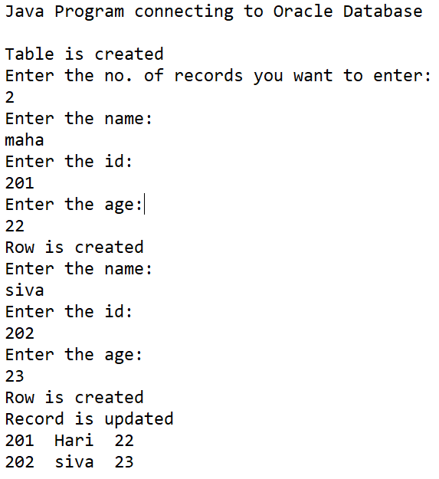

**RESULT:**

**PROGRAM:**

**SocketDemo.java**

import java.io.DataInputStream;

import java.io.DataOutputStream;

import java.io.IOException;

import java.net.Socket;

import java.net.UnknownHostException;

public class SocketDemo

{

private Socket socket = null;

private DataInputStream input = null;

private DataOutputStream output = null;

public SocketDemo(String address, Integer port){

try{

socket = new Socket(address,port);

input = new DataInputStream(System.in);

output = new DataOutputStream(socket.getOutputStream());

}catch(Exception e){

e.printStackTrace();

}

String line="";

while(!(line.equals("Done"))){

try{

line = input.readLine();

output.writeUTF(line);

}catch(Exception e){

e.printStackTrace();

}

}

try{

input.close();

output.close();

socket.close();

}catch(Exception e){

e.printStackTrace();

}

}

public static void main(String[] args){

SocketDemo client = new SocketDemo("127.0.0.1",5000);

}

}

**SocketDemoServer.java**

import java.io.BufferedInputStream;

import java.io.DataInputStream;

import java.io.IOException;

import java.net.ServerSocket;

import java.net.Socket;

public class SocketDemoServer{

private Socket socket = null;

private ServerSocket server = null;

private DataInputStream in = null;

public SocketDemoServer(int port){

try{

server = new ServerSocket(port);

System.out.println("Server started::");

System.out.println("Waiting for a client ......");

socket = server.accept();

System.out.println("Client accepted.");

in = new DataInputStream(new BufferedInputStream(socket.getInputStream()));

String line="";

while(!line.equals("Done")){

try{

line = in.readUTF();

System.out.println(line);

}catch(Exception i){

i.printStackTrace();

}

}

System.out.println("Closing connection");

socket.close();

in.close();

}catch(Exception i){

i.printStackTrace();

}

}

public static void main(String args[]){

SocketDemoServer server = new SocketDemoServer(5000);

}

}

**OUTPUT:**

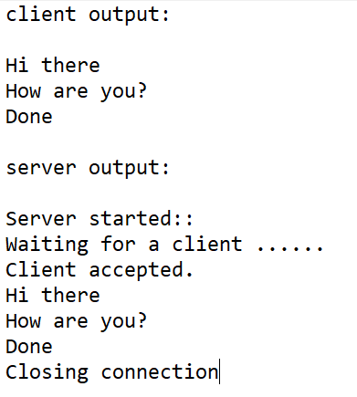

**RESULT:**

**PROGRAM:**

import java.awt.*;

import java.awt.event.*;

import javax.swing.JOptionPane;

class AWTForm extends Frame implements ActionListener

{

TextField tf1,tf2;

Button b1;

AWTForm()

{

this.addWindowListener(new WindowAdapter(){

public void windowClosing(WindowEvent e)

{

System.exit(0);

}

});

tf1 = new TextField(25);

tf1.setBounds(100,230,260,40);

tf2 = new TextField(25);

tf2.setBounds(100,360,260,40);

tf2.setEchoChar('*');

b1 = new Button("Submit");

b1.setBounds(100,450,130,30);

b1.setBackground(new Color(238,175,0));

b1.addActionListener(this);

this.setTitle("ShowroomKit");

this.setSize(1300,600);

this.setVisible(true);

this.setLayout(null);

this.add(tf1);

this.add(tf2);

this.add(b1);

}

public void actionPerformed(ActionEvent ae)

{

if(ae.getSource()==b1)

{

if(tf1.getText().isEmpty())

{

JOptionPane.showMessageDialog(null, "Enter the email ID","Error",JOptionPane.QUESTION_MESSAGE);

return;

}

if(tf2.getText().isEmpty())

{

JOptionPane.showMessageDialog(null, "Enter the password","Error",JOptionPane.QUESTION_MESSAGE);

return;

}

JOptionPane.showMessageDialog(null, "Login Successfull","Success",JOptionPane.PLAIN_MESSAGE);

}

}

public void paint(Graphics g)

{

Image img = Toolkit.getDefaultToolkit().getImage("shopping.jpg");

MediaTracker track = new MediaTracker(this);

track.addImage(img,0);

try{

track.waitForID(0);

}catch(InterruptedException ie){}

this.setBackground(new Color(244,241,236));

Font f = new Font("Arial",Font.PLAIN,30);

g.setFont(f);

g.setColor(Color.black);

g.drawString("Welcome to",100,100);

Font f2 = new Font("Arial",Font.ITALIC,28);

g.setFont(f2);

g.drawString("ShowroomKit",270,100);

g.drawImage(img,440,130,500,400,null);

Font f3 = new Font("Arial",Font.PLAIN,24);

g.setFont(f3);

g.drawString("Enter your Email ID",100,200);

g.drawString("Enter your Password",100,330);

}

public static void main(String args[])

{

AWTForm f = new AWTForm();

}

}

**OUTPUT:**

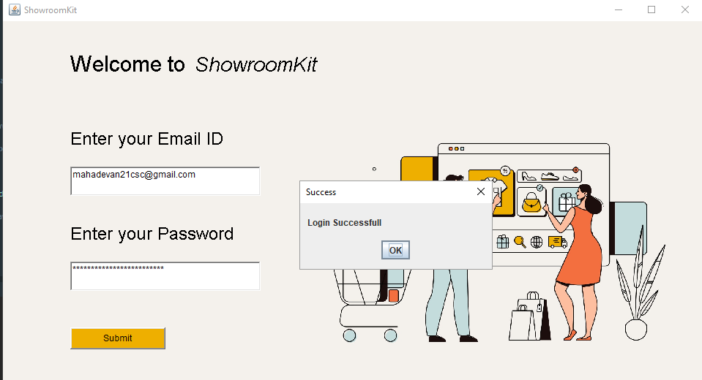

**RESULT:**